HADOOP PROGRAMS

Bash file:
export JAVA_HOME=$(readlink -f $(which javac) | awk 'BEGIN {FS="/bin"} {print $1}') export PATH=$(echo $PATH):$(pwd)/bin
export CLASSPATH=$(hadoop classpath)

Command to run it: source bash.sh

Programs:

Write a MapReduce program to analyse the given natural numbers and generate statistics for the number as Odd or Even and print their sum.

driver.java

package oddeven; import java.io.*; import java.util.*;
import org.apache.hadoop.mapred.*; import org.apache.hadoop.io.*; import org.apache.hadoop.fs.Path;

public class driver
{
public static void main(String args[]) throws IOException
{
JobConf conf=new JobConf(driver.class); conf.setMapperClass(mapper.class); conf.setReducerClass(reducer.class); conf.setOutputKeyClass(Text.class); conf.setOutputValueClass(IntWritable.class); FileInputFormat.addInputPath(conf, new Path(args[0])); FileOutputFormat.setOutputPath(conf,new Path(args[1])); JobClient.runJob(conf);
}
}

mapper.java

package oddeven; import java.io.*; import java.util.*;
import org.apache.hadoop.mapred.*;
public class mapper extends MapReduceBase implements Mapper<LongWritable , Text , Text , IntWritable>
{
public void map(LongWritable key,Text value,OutputCollector<Text,IntWritable> output,Reporter r) throws IOException
{
String[] line=value.toString().split(" "); for(String num:line){
int number=Integer.parseInt(num); if(number%2==0) {
output.collect(new Text("even"),new IntWritable(number));

}
else{

}
}
}
}

output.collect(new Text("odd"),new IntWritable(number));

reducer.java

package oddeven; import java.io.*; import java.util.*;
import org.apache.hadoop.mapred.*; import org.apache.hadoop.io.*;
public class reducer extends MapReduceBase implements Reducer<Text,IntWritable,Text,IntWritable>
{
public void reduce(Text key,Iterator<IntWritable> value,OutputCollector<Text,IntWritable> output ,Reporter r) throws IOException
{
int sum=0,count=0; while(value.hasNext()){
sum+=value.next().get(); count++;
}
output.collect(new Text("Sum of "+key+" Numbers"),new IntWritable(sum)); output.collect(new Text(key+" Number count"),new IntWritable(count));
}
}

oe.txt
1 2 3 4 5 6 7 8 9 10

Output:
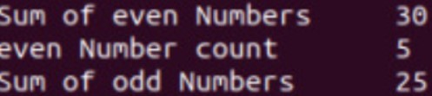

- Write a MapReduce program to analyze the given Weather Report Data and to generate a report with cities having maximum and minimum temperature for a particular year.

driver.java

package weather; import java.util.*; import java.io.*;
import org.apache.hadoop.mapred.*; import org.apache.hadoop.io.*; import org.apache.hadoop.fs.Path;

public class driver
{
public static void main(String args[]) throws IOException
{
JobConf conf=new JobConf(driver.class); conf.setMapperClass(mapper.class); conf.setReducerClass(reducer.class); conf.setOutputKeyClass(Text.class); conf.setOutputValueClass(DoubleWritable.class); FileInputFormat.addInputPath(conf, new Path(args[0])); FileOutputFormat.setOutputPath(conf,new Path(args[1])); JobClient.runJob(conf);
}
}

mapper.java

package weather; import java.util.*; import java.io.*;
import org.apache.hadoop.mapred.*; import org.apache.hadoop.io.*;
public class mapper extends MapReduceBase implements Mapper<LongWritable, Text,Text,DoubleWritable>{
public void map(LongWritable key , Text value , OutputCollector<Text,DoubleWritable> output, Reporter r) throws IOException
{
String line=value.toString(); String year=line.substring(15,19);
Double temp=Double.parseDouble(line.substring(87,92)); output.collect(new Text(year), new DoubleWritable(temp));
}
}

reducer.java

package weather; import java.util.*; import java.io.*;
import org.apache.hadoop.mapred.*; import org.apache.hadoop.io.*;
class reducer extends MapReduceBase implements Reducer<Text,DoubleWritable,Text,DoubleWritable> {
public void reduce(Text key, Iterator<DoubleWritable> value, OutputCollector<Text,DoubleWritable> output, Reporter r) throws IOException{
Double max=-9999.0; Double min=9999.0; while(value.hasNext()){
Double temp=value.next().get(); max=Math.max(max,temp); min=Math.min(min,temp);
}
output.collect(new Text("Max temp at "+ key), new DoubleWritable(max)); output.collect(new Text("Min temp at "+ key), new DoubleWritable(min));
}
}

Input.txt

0067011990999991950051507004+68750+023550FM-12+038299999V0203301N00671220
001CN9999999N9+00001+99999999999
0043011990999991950051512004+68750+023550FM-12+038299999V0203201N00671220
001CN9999999N9+00221+99999999999
0043011990999991950051518004+68750+023550FM-12+038299999V0203201N00261220
001CN9999999N9-00111+99999999999
0043012650999991949032412004+62300+010750FM-12+048599999V0202701N0046122
0001CN0500001N9+01111+99999999999
0043012650999991949032418004+62300+010750FM-12+048599999V0202701N0046122
0001CN0500001N9+00781+99999999999

Output:
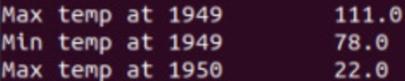

- Write a MapReduce program to analyze the given Earthquake Data and generate statistics with region and magnitude/ region and depth/ region and latitude/ region and longitude.

driver.java

package earthquake; import java.util.*; import java.io.*;
import org.apache.hadoop.mapred.*; import org.apache.hadoop.io.*; import org.apache.hadoop.fs.Path;

public class driver
{
public static void main(String args[]) throws IOException
{
JobConf conf=new JobConf(driver.class); conf.setMapperClass(mapper.class); conf.setReducerClass(reducer.class); conf.setOutputKeyClass(Text.class); conf.setOutputValueClass(DoubleWritable.class); FileInputFormat.addInputPath(conf, new Path(args[0])); FileOutputFormat.setOutputPath(conf,new Path(args[1])); JobClient.runJob(conf);
}

mapper.java

package earthquake; import java.util.*; import java.io.*;
import org.apache.hadoop.mapred.*; import org.apache.hadoop.io.*;
public class mapper extends MapReduceBase implements Mapper<LongWritable, Text,Text,DoubleWritable>
{
public void map(LongWritable key , Text value , OutputCollector<Text,DoubleWritable> output, Reporter r) throws IOException
{
String[] line=value.toString().split(","); Double longi=Double.parseDouble(line[7]);
output.collect(new Text(line[11]), new DoubleWritable(longi));
}
}

reducer.java

package earthquake; import java.util.*; import java.io.*;
import org.apache.hadoop.mapred.*; import org.apache.hadoop.io.*;
class reducer extends MapReduceBase implements Reducer<Text,DoubleWritable,Text,DoubleWritable> {

public void reduce(Text key, Iterator<DoubleWritable> value, OutputCollector<Text,DoubleWritable> output, Reporter r) throws IOException
{
Double max=-9999.0; while(value.hasNext())
{
Double temp=value.next().get(); max=Math.max(max,temp);
}
output.collect(new Text(key), new DoubleWritable(max));
}

Output:
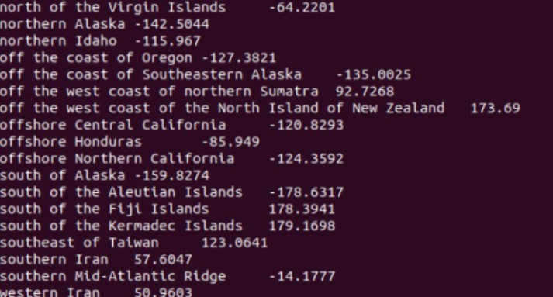

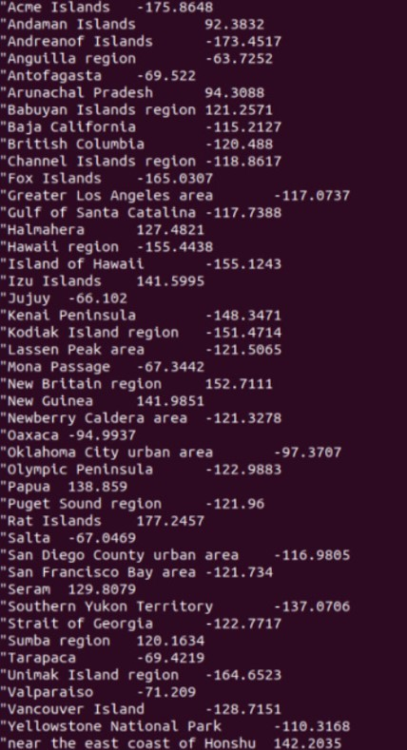

- Write a MapReduce program to analyze the given Insurance Data and generate a statistics report with the construction building name and the count of building/county name and its frequency.

driver.java

package insurance; import java.io.*; import java.util.*;
import org.apache.hadoop.mapred.*; import org.apache.hadoop.io.*; import org.apache.hadoop.fs.Path;

public class driver
{
public static void main(String args[]) throws IOException
{
JobConf conf=new JobConf(driver.class); conf.setMapperClass(mapper.class); conf.setReducerClass(reducer.class); conf.setOutputKeyClass(Text.class); conf.setOutputValueClass(IntWritable.class); FileInputFormat.addInputPath(conf, new Path(args[0])); FileOutputFormat.setOutputPath(conf,new Path(args[1])); JobClient.runJob(conf);
}
}

mapper.java

package insurance; import java.io.*; import java.util.*;
import org.apache.hadoop.mapred.*; import org.apache.hadoop.io.*;

public class mapper extends MapReduceBase implements Mapper<LongWritable , Text , Text , IntWritable>
{
public void map(LongWritable key,Text value,OutputCollector<Text,IntWritable> output,Reporter r) throws IOException
{
String[] line=value.toString().split(","); output.collect(new Text(line[2]),new IntWritable(1));
}
}

reducer.java

package insurance; import java.io.*; import java.util.*;
import org.apache.hadoop.mapred.*; import org.apache.hadoop.io.*;
public class reducer extends MapReduceBase implements Reducer<Text,IntWritable,Text,IntWritable>
{
public void reduce(Text key,Iterator<IntWritable> value,OutputCollector<Text,IntWritable> output ,Reporter r) throws IOException
{
int sum=0; while(value.hasNext())
{
sum+=value.next().get();
}
output.collect(key,new IntWritable(sum));
}
}

Output:
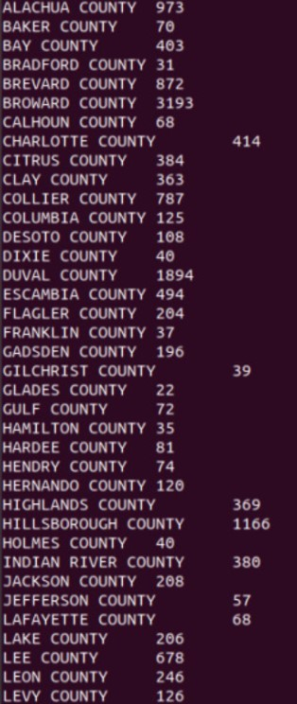
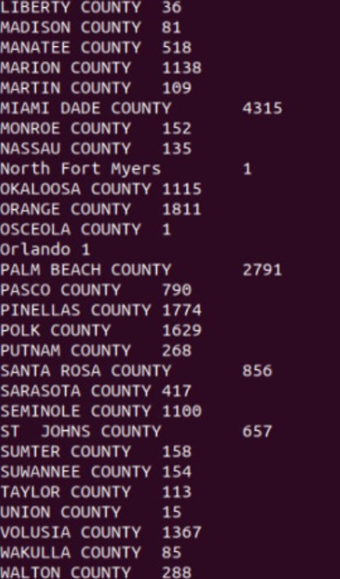

- Write a MapReduce program using Java, to analyze the given Sales Records over a period of time and generate data about the country’s total sales, and the total number of the products. Country’s total sales and the frequency of the payment mode.

driver.java

package sales; import java.io.*; import java.util.*;
import org.apache.hadoop.mapred.*; import org.apache.hadoop.io.*; import org.apache.hadoop.fs.Path;

public class driver
{
public static void main(String args[]) throws IOException
{
JobConf conf=new JobConf(driver.class); conf.setMapperClass(mapper.class); conf.setReducerClass(reducer.class); conf.setOutputKeyClass(Text.class); conf.setOutputValueClass(IntWritable.class);
FileInputFormat.addInputPath(conf, new Path(args[0])); FileOutputFormat.setOutputPath(conf,new Path(args[1])); JobClient.runJob(conf);
}
}

mapper.java

package sales; import java.io.*; import java.util.*;
import org.apache.hadoop.mapred.*; import org.apache.hadoop.io.*;

public class mapper extends MapReduceBase implements Mapper<LongWritable , Text , Text , IntWritable>
{
public void map(LongWritable key,Text value,OutputCollector<Text,IntWritable> output,Reporter r) throws IOException
{
String[] line=value.toString().split(","); int price=Integer.parseInt(line[2]); String cardtype=line[3];
String Country=line[7];
output.collect(new Text("Country "+Country),new IntWritable(price)); output.collect(new Text("CardType "+cardtype),new IntWritable(1));
}
}

reducer.java

package sales;

import java.io.*; import java.util.*;
import org.apache.hadoop.mapred.*; import org.apache.hadoop.io.*;

public class reducer extends MapReduceBase implements Reducer<Text,IntWritable,Text,IntWritable>
{
public void reduce(Text key,Iterator<IntWritable> value,OutputCollector<Text,IntWritable> output ,Reporter r) throws IOException
{
int sum=0; while(value.hasNext())
{
sum+=value.next().get();
}
output.collect(new Text(key),new IntWritable(sum));
}
}

Output:
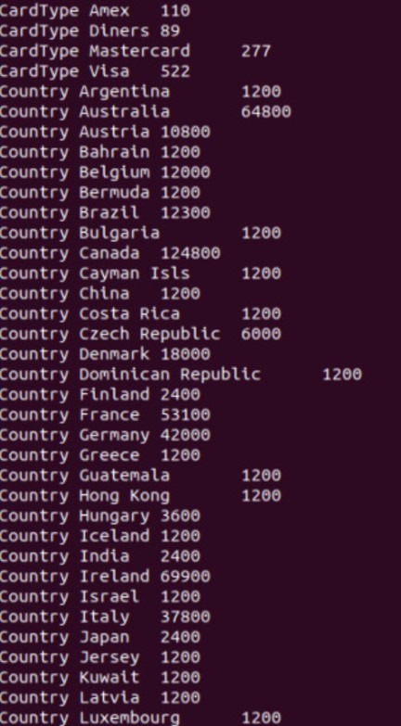
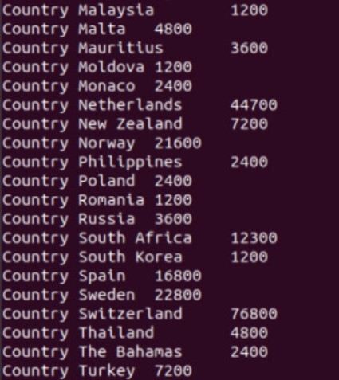

- Write a MapReduce program using Java, to analyze the given employee record data and generate a statistics report with the total number of Female and Male Employees and their average salary.

driver.java

package employee; import java.io.*; import java.util.*;
import org.apache.hadoop.mapred.*; import org.apache.hadoop.io.*; import org.apache.hadoop.fs.Path;

public class driver
{
public static void main(String args[]) throws IOException
{
JobConf conf=new JobConf(driver.class); conf.setMapperClass(mapper.class); conf.setReducerClass(reducer.class); conf.setOutputKeyClass(Text.class);
conf.setOutputValueClass(DoubleWritable.class); FileInputFormat.addInputPath(conf,new Path(args[0])); FileOutputFormat.setOutputPath(conf,new Path(args[1])); JobClient.runJob(conf);
}
}

mapper.java

package employee; import java.io.*; import java.util.*;
import org.apache.hadoop.mapred.*; import org.apache.hadoop.io.*;
class mapper extends MapReduceBase implements Mapper<LongWritable , Text , Text , DoubleWritable> {

public void map(LongWritable key, Text value, OutputCollector<Text,DoubleWritable> output ,Reporter r) throws IOException
{
String[] line=value.toString().split("\\t"); salary=Double.parseDouble(line[8]);
output.collect(new Text(line[3]), new DoubleWritable(salary));
}

}

reducer.java

package employee; import java.io.*; import java.util.*;
import org.apache.hadoop.mapred.*; import org.apache.hadoop.io.*;
class reducer extends MapReduceBase implements Reducer<Text,DoubleWritable,Text,DoubleWritable> {
public void reduce(Text key,Iterator<DoubleWritable> value , OutputCollector<Text,DoubleWritable> output ,Reporter r) throws IOException
{
int count=0; Double sum=0.0;
while(value.hasNext()){
sum+=value.next().get(); count+=1;
}
output.collect(new Text(key+" Average"), new DoubleWritable(sum/count)); output.collect(new Text(key+" Count"), new DoubleWritable(count));
}
}

Output:
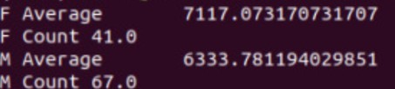

- Write a MapReduce program using java, to demonstrate matrix multiplication. driver.java
package matrix; import java.util.*; import java.io.*;
import org.apache.hadoop.fs.Path; import org.apache.hadoop.mapred.*; import org.apache.hadoop.io.*;

public class driver{
public static void main(String args[]) throws IOException
{
JobConf conf=new JobConf(driver.class); conf.setMapperClass(mapper.class); conf.setReducerClass(reducer.class); conf.setOutputKeyClass(Text.class); conf.setOutputValueClass(Text.class); FileInputFormat.addInputPath(conf,new Path(args[0])); FileOutputFormat.setOutputPath(conf,new Path(args[1])); JobClient.runJob(conf);

}
}

mapper.java

package matrix; import java.util.*; import java.io.*;
import org.apache.hadoop.mapred.*; import org.apache.hadoop.io.*;
class mapper extends MapReduceBase implements Mapper<LongWritable, Text, Text,Text>
{
public void map(LongWritable key, Text value, OutputCollector<Text,Text> output, Reporter r) throws IOException
{
String line[]=value.toString().split(","); Text OutputKey=new Text();
Text OutputValue=new Text(); if(line[0].equals("A"))
{

for(int i=0;i<3;i++)
{
OutputKey.set(line[1]+","+i); OutputValue.set("A,"+line[2]+","+line[3]); output.collect(OutputKey,OutputValue);

}
else
{
}

for(int i=0;i<2;i++)
{

OutputKey.set(i+","+line[2]); OutputValue.set("B,"+line[1]+","+line[3]); output.collect(OutputKey,OutputValue);

}
}
}
}

reducer.java

package matrix; import java.util.*; import java.io.*;
import org.apache.hadoop.mapred.*; import org.apache.hadoop.io.*;
public class reducer extends MapReduceBase implements Reducer<Text,Text,Text,Text>
{
public void reduce(Text key ,Iterator<Text> value , OutputCollector<Text,Text> output,Reporter r) throws IOException
{
HashMap<Integer,Float> a=new HashMap<Integer,Float>(); HashMap<Integer,Float> b=new HashMap<Integer,Float>(); String[] v;
while(value.hasNext())
{
v=value.next().toString().split(",");

if(v[0].equals("A"))
{

}
else
{

}
}
a.put(Integer.parseInt(v[1]),Float.parseFloat(v[2]));

b.put(Integer.parseInt(v[1]),Float.parseFloat(v[2]));

float aij,bij, result=0.0f; for(int i=0;i<5;i++)
{
aij=a.containsKey(i) ? a.get(i): 0.0f; bij=b.containsKey(i) ? b.get(i): 0.0f; result+=aij*bij;
}
if(result!=0.0f)
{
output.collect(null,new Text(key+","+Float.toString(result)));
}
}

}

input.txt

A,0,0,1.0
A,0,1,1.0
A,0,2,1.0
A,0,3,1.0
A,0,4,1.0
A,1,0,2.0
A,1,1,2.0
A,1,2,2.0
A,1,3,2.0
A,1,4,2.0
B,0,0,1.0
B,0,1,1.0
B,0,2,1.0
B,1,0,1.0
B,1,1,1.0
B,1,2,1.0
B,2,0,1.0
B,2,1,1.0
B,2,2,1.0
B,3,0,1.0
B,3,1,1.0
B,3,2,1.0

B,4,0,1.0
B,4,1,1.0
B,4,2,1.0

Output:
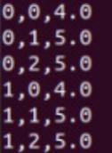

- Write a MapReduce program using java, to find out the word count from a given input file.

driver.java

package wordcount;

import java.io.*; import java.util.*;
import org.apache.hadoop.mapred.*; import org.apache.hadoop.io.*; import org.apache.hadoop.fs.Path;

public class driver
{
public static void main(String args[]) throws Exception
{
JobConf conf=new JobConf(driver.class); conf.setMapperClass(mapper.class); conf.setReducerClass(reducer.class); conf.setOutputKeyClass(Text.class); conf.setOutputValueClass(IntWritable.class); FileInputFormat.addInputPath(conf, new Path(args[0])); FileOutputFormat.setOutputPath(conf , new Path(args[1])); JobClient.runJob(conf);

}
}

mapper.java
package wordcount; import java.io.*; import java.util.*;
import org.apache.hadoop.mapred.*; import org.apache.hadoop.io.*;

public class mapper extends MapReduceBase implements Mapper<LongWritable , Text , Text , IntWritable>
{
public void map(LongWritable key , Text value, OutputCollector<Text,IntWritable> output, Reporter r) throws IOException
{
String line[]=value.toString().split(" "); for(String a:line){
output.collect(new Text(a),new IntWritable(1));
}
}
}

reducer.java

package wordcount; import java.io.*; import java.util.*;
import org.apache.hadoop.mapred.*; import org.apache.hadoop.io.*;
class reducer extends MapReduceBase implements Reducer<Text , IntWritable , Text , IntWritable>
{
public void reduce(Text key,Iterator<IntWritable> value, OutputCollector<Text,IntWritable> output, Reporter r) throws IOException
{
int count=0; while(value.hasNext())
{
count+=value.next().get();
}
output.collect(new Text(key),new IntWritable(count));
}

}

input.txt

HDFS is a storage unit of Hadoop MapReduce is a processing tool of Hadoop
Output:
